Project Development Phase Performance Test

Date | 20 February 2026
Team ID | LTVIP2026TMIDS79334
Project Name | Empowering India: Analysing the Evolution of Union Budget Allocations for  Sustainable Growth
Maximum
Marks

Model Performance Testing:
Project team shall fill the following information in model performance testing template.

S.N  o. | Paramete  r | Screenshot / Values
1 | . Data Rendered | 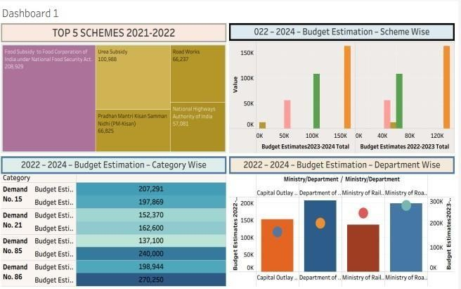

 |  | 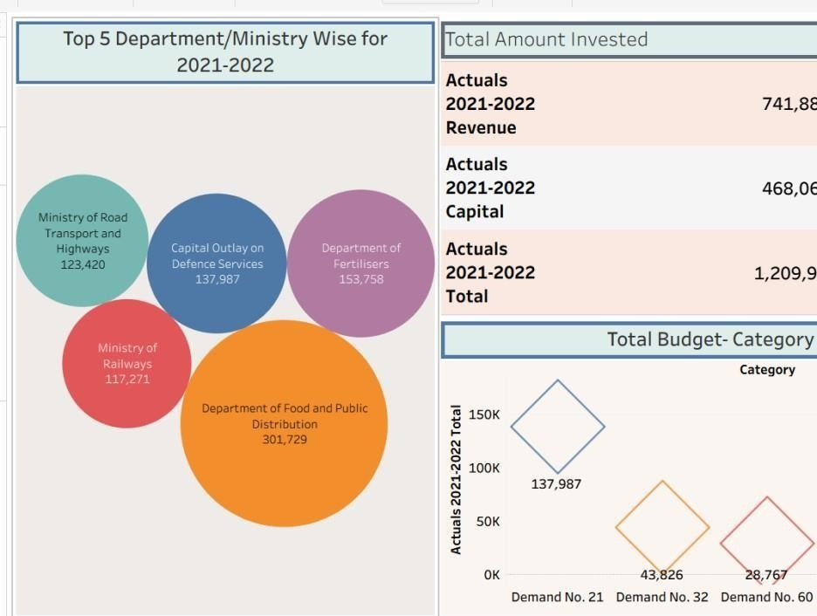
2. | Data  Preproces sing | 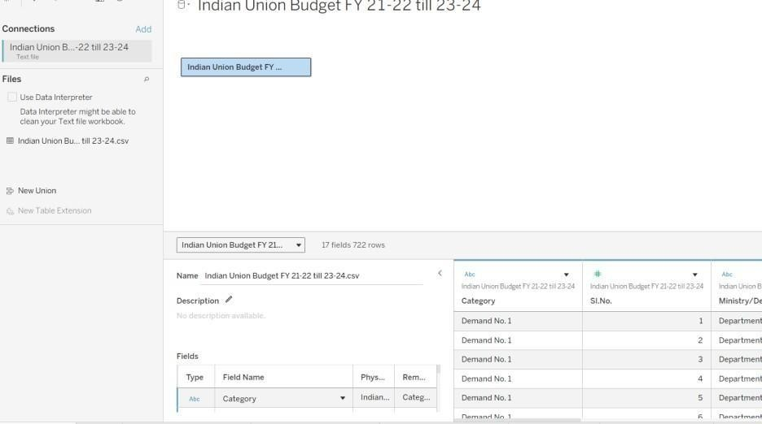
3. | Utilization of Filters | Category and Measure Names (2022–2024 Budget Estimates).

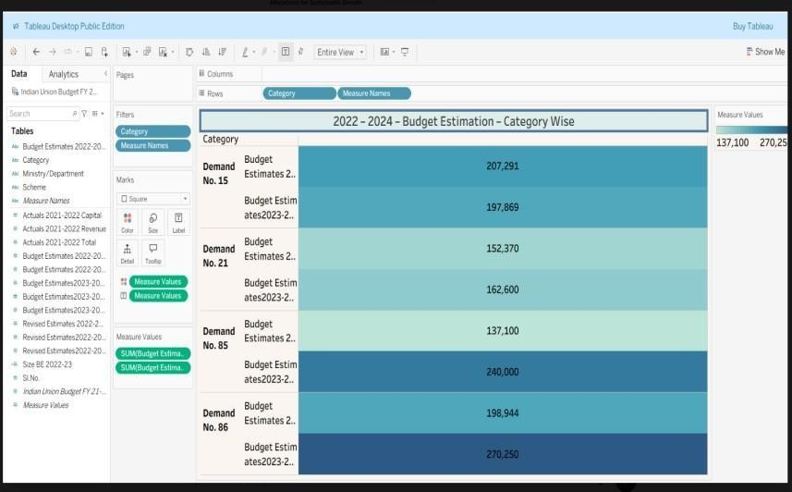
Budget Estimates (2022–2024) to display department-wise budget data.

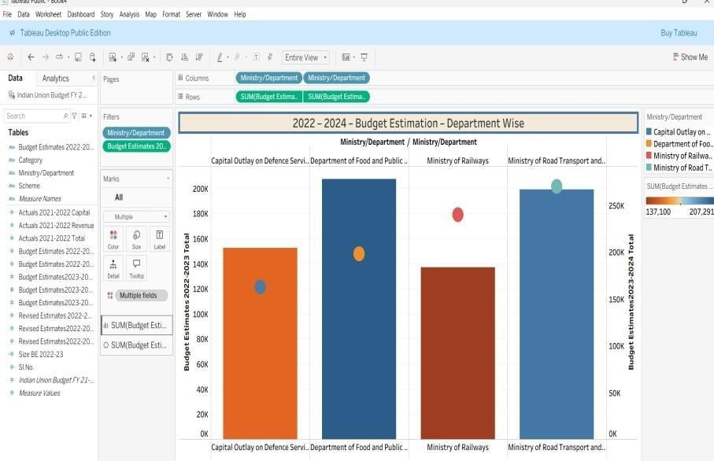
Filtered by Scheme and selected specific Budget Estimate years (2022– 2024) to display scheme-wise allocations.

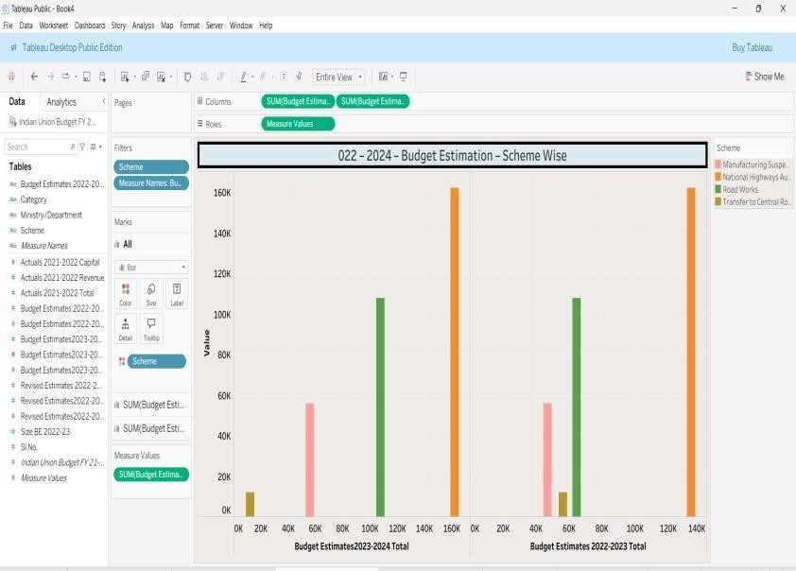
Filters Used (One Line):
Applied Ministry/Department filter to display only the Top 5 departments for 2021–2022.

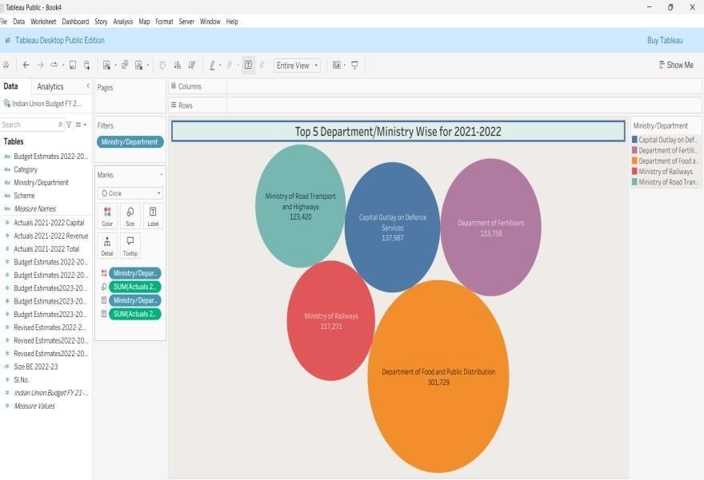
Filters Used (One Line):
Applied Measure Names filter to display only Actuals 2021–2022 Revenue, Capital, and Total.

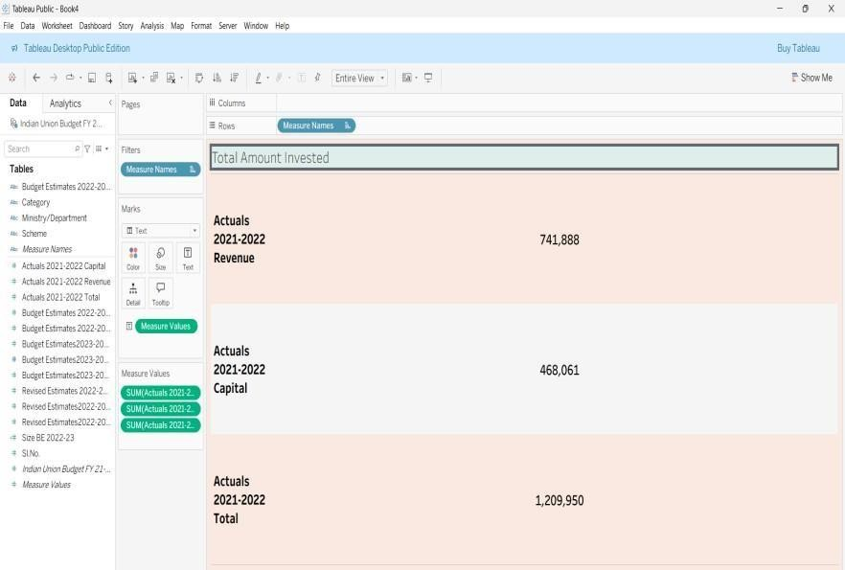
Filters Used (One Line):
Applied Category filter to display selected demand numbers only.

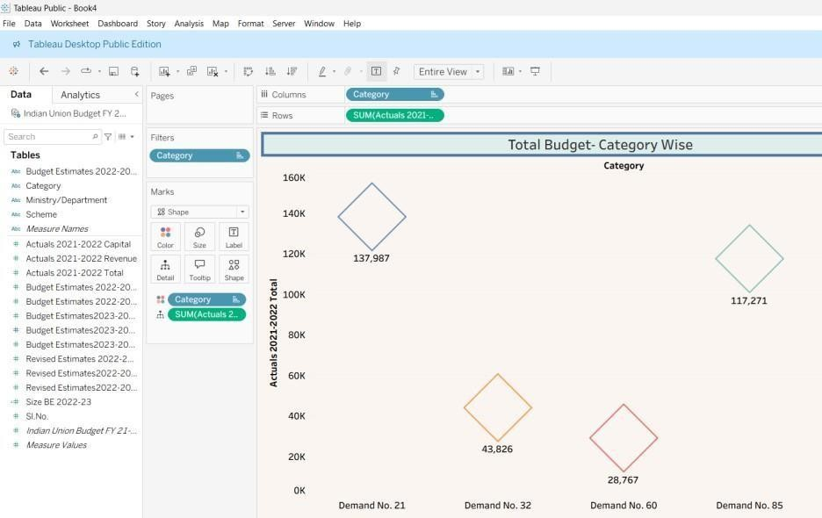

4. | Calculatio n fields Used | SUM([Budget Estimates]) – This calculation adds all budget allocation values together to show the total allocation for the selected category and year.

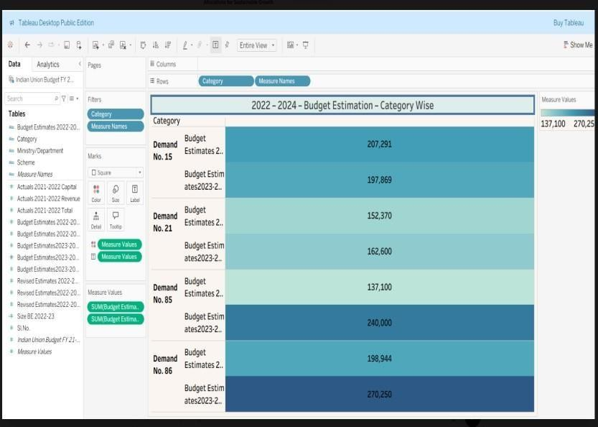
Budget Estimates (2022–2024) to display department-wise budget data.


Calculation Used (One Line):
SUM([Budget Estimates])


Calculation Used (One Line):
SUM([Actuals 2021–2022 Total]) to calculate total expenditure for each ministry.


Calculations Used (One Line):

SUM([Actuals 2021–2022 Revenue]), SUM([Actuals 2021–2022 Capital]), and SUM([Actuals 2021–2022 Total]) to compute total invested amounts.


Calculations Used (One Line):
SUM([Actuals 2021–2022 Total]) to calculate total expenditure for each category.

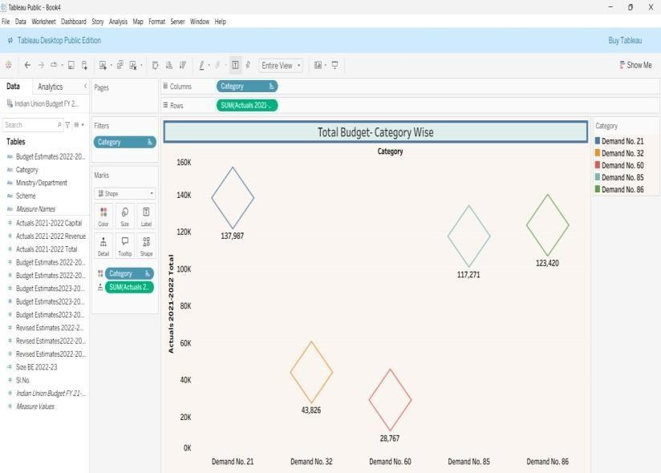

5. | Dashboar d design | 7 VISUALIZATIONS

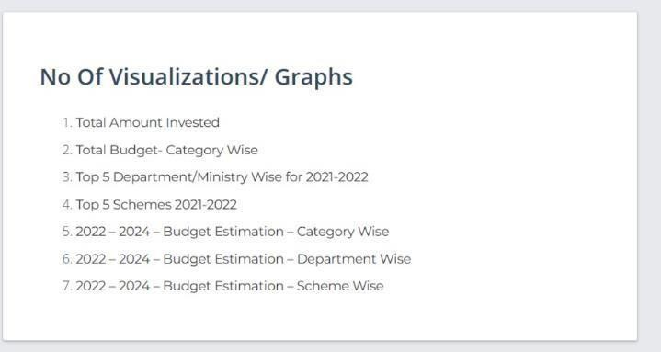

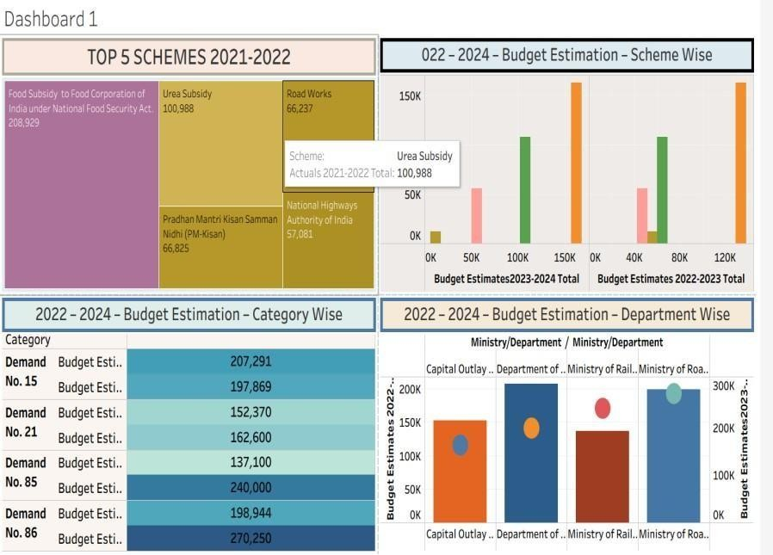

 |  | 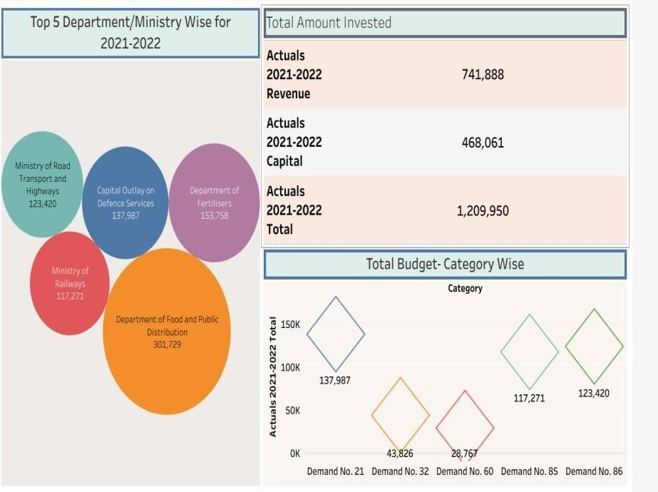
6 | Story  Design | 7 VISUALIZATIONS  
